Interaction of Vitamin D and Tumor Necrosis Factor-α can modulate the Outcomes of ICSI
Ali A. Bendary MD₁, Yasmin M. Marei MD₂, Walid M. Elnagar₃

₁ Department of Obstetrics & Gynecology, Faculty of Medicine, Benha University
₂ Department of Medical Biochemistry, Faculty of Medicine, Benha University
₃Department of Obstetrics & Gynecology, Faculty of Medicine, Zagazig University

Abstract
Objectives: To investigate the relation between vitamin D sufficiency (VDS) levels and outcomes of ICSI for infertile women
Patients &Methods: 104 infertile women were clinically evaluated and given blood samples for estimation of serum levels of tumor necrosis factor-α (TNF-α) and 25-Hydroxy VD (25-OHVD) and were categorized according to VDS levels. All women underwent frozen embryo transfer after controlled ovarian stimulation. The chemical (CPR) and clinical pregnancy rates (CLPR), the early pregnancy loss (EPL), and the successful pregnancy rate (SPR) were evaluated concerning the estimated levels of 25-OHVD and TNF-α.
Results: The CPR was 53.8% and was higher among VD deficient (VDD) women. The CLPR was 36.5% and showed an insignificant difference according to VDS status. The EPR was 20.2%, while the SPR was 16.3% and was significantly higher in VDS than in VDD women. There was a negative significant correlation between serum levels of 25-OHVD and TNF-α. The CPR and CLPR showed negative significant correlations with serum TNF-α levels. The SPR showed positive and negative significant correlations with serum levels of 25-OHVD and TNF-α, respectively.
Conclusion: VD might improve ICSI outcomes through its modulatory action on the systemic inflammatory milieu. Pro-inflammatory cytokines had deleterious effects on ICSI outcomes and the balance between pre- and anti-inflammatory cytokines must be corrected before committing ART procedures
Keywords: Vitamin D, Tumor necrosis factor-α, ICSI, Early pregnancy loss, Successful outcome
Introduction
Vitamin D (VD) is a secosteroid, which is derived from cholesterol and has a vital role in the maintenance of human health with multiple extra-skeletal effects ⁽¹⁾. Serum VD is essential for both the mother's and the fetus's health and its deficiency can increase the risk of fetal abnormalities including fetal heart abnormalities ⁽²⁾. Maternal VD deficiency (VDD) was found to be associated with adverse maternal outcomes and an increased risk of pregnancy complications ⁽³⁾ and causes placental dysplasia with subsequent intrauterine growth retardation ⁽⁴⁾.
Vitamin D acting on VD receptor (VDR), which showed widespread distribution almost in all immune cells, induces inhibition of the production of pro-inflammatory cytokines ⁽⁵⁾, reduction of the antigen-presenting capacity and T-cell stimulatory ability by antigen-presenting cells ⁽⁶⁾ with upregulation of regulatory T cells and the promotion of the shift of Th1 towards the Th2 cells with its regulatory anti-inflammatory actions ⁽⁷⁾.
Tumor necrosis factor-alpha (TNF-α) is a homotrimer of 17 kDa protein consisting of 157 amino acids and is mainly produced by activated macrophages, T lymphocytes, and natural killer cells ⁽⁸⁾. TNF-α has potent inflammatory and apoptotic actions ⁽⁹⁾.
Inflammatory cytokines showed intimate relation to female infertility and deliriously affected the outcomes of assisted reproductive technology (ART) and its high concentrations in follicular fluid affect the development and fertilization of oocytes ⁽¹⁰⁾. Activated TNF-α signaling due to restraint stress and elevation of levels of corticotrophin-releasing hormone impair oocyte competence and affect fertility and outcomes of ART ⁽¹¹⁾.

Objectives
This study tried to assess the impact of VDS state on outcomes of ICSI for infertile women

Design:
Prospective interventional non-randomized comparative study

Setting
Department of Obstetrics & Gynecology, Faculty of Medicine, Benha University, in conjunction with multiple private centers in Benha and Cairo; Egypt

Ethical considerations
The preliminary approval of the study protocol was obtained from the Ethical Committee, Faculty of Medicine, Benha University on 17-5-2020, and the final approval was obtained after the completion of case collection on 21-11-2022. All women who fulfilled the inclusion criteria were asked to sign the written fully informed consent after a discussion of the study protocol with the author.

Blindness
The collected samples were sent to clinical pathologists as numbered innominate samples without clinical diagnosis or indication for estimation of VD. On the other side, the obstetrician was also blinded about the results of VD level estimations till the end of the study. Thereafter, the results of lab work and ICSI outcomes were interpreted against each other.

Patients
All infertile women attending the clinics of ART were evaluated clinically, and by ultrasonographic examination and had lab investigations essential for the diagnosis and preparation if included in the study.

Exclusion criteria
Age older than 45 years, infertility secondary to endocrinopathy, congenital malformation, exposure to radio-or chemotherapy, ovarian or uterine diseases, obesity grade II with body mass index (BMI) >35 kg/m² to guard against the effect of obesity of serum levels of the studied parameters, attendance during winter session to exclude the seasonal effects on VD levels or refusal to participate in the study.

Inclusion criteria
Infertile women assigned and prepared for frozen embryo transfer, free of the exclusion criteria, and signed the written fully informed consent to participate in the study and undergo the assigned investigation and receive the appropriate therapies were included in the study. Ten fertile women with age- and BMI cross-matched to the included infertile women and free of inclusion and exclusion criteria were enrolled as a control group for the study investigations.

Evaluation of VD sufficiency status:
The enrolled women were graded according to the estimated serum 25-hydroxy vitamin D (25-OHVD) as having VDS, insufficiency, or VDD if serum 25-OHVD levels were ≥75 nmol/L, 50-75 nmol/L or <50 nmol/L, respectively. Women who had VDD were categorized as mild, moderate, and severe VDD if 25-OHD serum levels were 25-50 nmol/L, 12.5-25 nmol/L, and <12.5 nmol/L, respectively ⁽¹²⁾.

Laboratory investigations
Blood samples were obtained at the time of clinic attendance under complete aseptic conditions, and after clotting centrifuged for 10-min at 3000 rpm, and the separated serum was stored at -80ºC till ELISA assayed for estimation of serum levels of human 25-OHVD ⁽¹³⁾ and human TNF-α ⁽¹⁴⁾ using ELISA kit (Abcam Inc., San Francisco, USA; catalog no. ab213966, ab46087).

Study protocol
Ovarian stimulation protocol was provided according to hospital guidelines using the gonadotrophin-releasing hormone (GnRH) flexible antagonist protocol in the form of daily subcutaneous injection of 300-600 IU of Gonal F (75 IU; 5.5µg, Merck Serono Ltd, UK) starting on the 2nd day of the cycle and cetrorelix (Cetrotide®, Merck, Germany) 250 µg daily was started when the dominant follicle reached 14 mm till the triggering day. Two ampoules of triptorelin acetate (Decapeptyl, Ferring Pharmaceuticals Ltd., Wittland, Germany; 0.1 mg, subcutaneous injection) was given as triggering when the mean diameter of the leading follicle reached ≥18 mm or >3 follicles reached a mean diameter of ≥16 mm. TVU-guided oocyte retrieval was performed 36 hours later and fertilization was carried out by intracytoplasmic sperm injection (ICSI).
The day-3 embryos are graded as good (G grade) if it contains 6-9 symmetric cells with no fragmentation, as fair (F grade) if cells are symmetric but there is only minor fragmentation and as poor (P grade) if cells are asymmetric with no or moderate fragmentation ⁽¹⁵⁾.
On the 2nd day of the cycle estradiol valerate (Progynova, 2 mg, Bayer Schering Pharma, UK) was given in a dose of 2 mg, and higher doses were gradually started till endometrial thickness was ≥8 mm, wherein the progesterone therapy was started as intra-vaginal progesterone (prontogest 400mg progesterone vaginal supp, Merck Serono, UK, once daily) and embryo transfer was performed 5-days later. Progesterone therapy was continued till the blood pregnancy test was performed 14 days later and the chemical pregnancy rate was recorded. Pregnancy was assured by abdominal US imaging to detect a viable gestational sac and a clinical pregnancy rate was registered. Progesterone therapy started as luteal phase support and was continued till the 10th gestational week ⁽¹⁶⁾.

Study outcome
The study outcome is the relation between serum levels of 25-OHVD and TNF-α that were estimated at enrolment and the chemical and clinical pregnancy rates, the rates of early pregnancy loss that was defined as pregnancy loss before the 12th gestational week (GW), and successful pregnancy rate, which is defined as the frequency of women continued their pregnancy after the 12th GW.

Statistical analysis
The obtained data were analyzed using One-way ANOVA and Chi-square (X² test) tests. Pearson's correlation analysis was applied to evaluate correlations between at-enrolment serum levels of 25-OHVD and TNF-α and ICSI outcomes using the IBM® SPSS® Statistics (Version 22, 2015; Armonk, USA) for Windows statistical package. P value <0.05 was considered statistically significant.

Results
The study included 104 infertile women after excluding 18 women for having uterine anomalies (n=2), obesity of grade II (n=7), endocrinopathy (n=4), and autoimmune disorders (n=5). Enrolment data of these 104 women are shown in table 1.

Table (1): Enrolment data of studied infertile women
Variables |  | Findings
Age (years) | <25 | 4 (3.8%)
 | 25-30 | 27 (26%)
 | >30-35 | 43 (41.4%)
 | >35 | 30 (28.8%)
 | Total | 32.3±4.2
Body mass index (kg/m²) | Overweight (<30) | 37 (35.6%)
 | Obese I (>30-34.99) | 67 (64.4%)
 | Total | 31.3±1.8
Blood pressure measures (mmHg) | Systolic | 117.5±3.4
 | Diastolic | 83.9±3.2
Random blood glucose (mg/dl) |  | 97.3±9.9

The mean serum 25-OHVD estimated in all studied samples was 44.63±22.3; range: 8.3-80.5 nmol/L and was significantly (P<0.001) lower than the level estimated in control samples (79.32±2.22; range: 76.4-83.4 nmol/L). Estimated serum 25-OHVD level was sufficient in 12 samples (11.5%), insufficient in 41 samples (39.5%), and deficient in 51 samples (49%), (Fig. 1). Further, the estimated 25-OHVD level in samples of women had VDD indicated mild, moderate and severe VDD in 23, 16 and 12 samples, respectively as shown in figure 2.

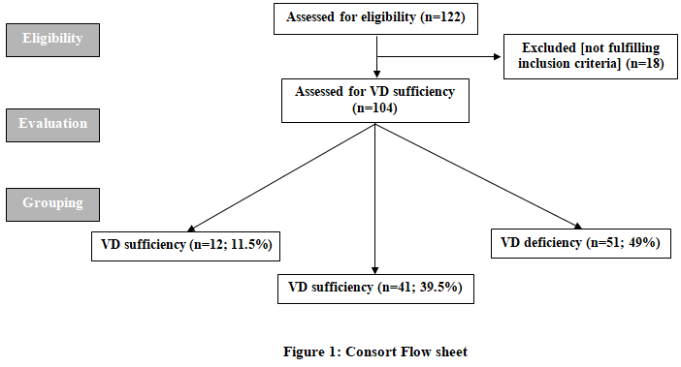
Serum levels of TNF-α estimated in patients' samples (3.3±0.63 ng/ml) were significantly (p<0.001) higher in comparison to levels estimated in control samples (1.9±0.47 ng/ml). Serum levels of TNF-α estimated in samples of patients who had SVD were non-significantly (p=0.144) lower, while were significantly (p=0.029) lower in comparison to levels estimated in samples of patients who had insufficient VD and VDD, respectively with non-significantly high levels estimated in samples of patients had VDD than samples of patients had VD insufficiency (Fig. 3).

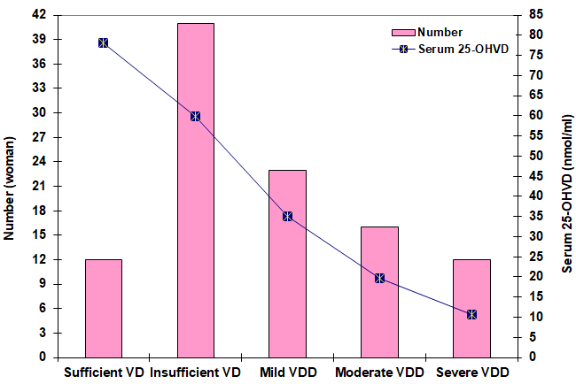

Fig. (2): Patients' distribution among VD sufficiency statuses with mean levels of 25-OHVD estimated in samples of each category

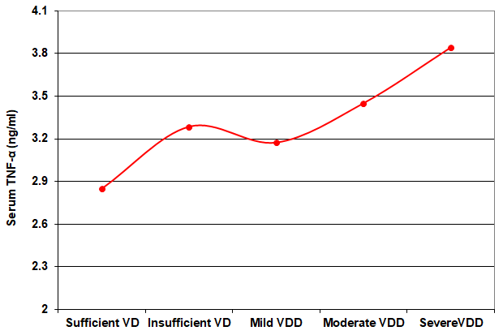

Fig. (3): Mean Serum TNF-α (ng/ml) levels estimated in samples of studied women categorized according to VD sufficiency status

During the study duration, 56 women got positive pregnancy tests for a CPR rate of 53.8%; CPR among VDD women was higher with significant (p=0.042) and insignificant (P=0.777) differences in comparison to the rate detected among women who had VD insufficiency and sufficiency, respectively, with non-significant (p=0.302) difference in favor of women had SVD. Thirty-eight women (67.9%) of the 56 women who had positive chemical pregnancies developed positive clinical pregnancies for a CLPR rate of 36.5% among the total study population. Women who had SVD had non-significantly higher CLPR compared to women who had insufficient (p=0.972) and deficient (p=0.768) VD levels with non-significant (p=0.724) differences in favor of women who had insufficient VD levels.
Unfortunately, 21 women (55.3%) of those who had clinical pregnancy, developed EPL for a rate of 20.2% among total women. The successful pregnancy rate of women who had clinical pregnancies was 44.7% and 16.3% among total enrolled women. The SPR among women who had SVD was higher with a significant (P=0.033) difference than the rate reported in VDD women and was non-significant (P=0.094) compared to the rate among women who had VD insufficiency who showed non-significantly (P=0.092) higher successful pregnancy rate than VDD women (Table 2, Fig. 4).

Table (2): Patients' outcomes of ICSI categorized according to VD sufficiency status
Variables | Sufficiency (n=12) | Insufficiency (n=41) | Deficiency (n=51) | Total (n=104)
Positive chemical pregnancy rate* | 7 (58.3%) | 17 (41.5%) | 32 (62.7%) | 56 (53.8%)
Positive clinical pregnancy rate† | 5 (71.4%) | 12 (70.6%) | 21 (41.2%) | 38 (67.9%)
Early pregnancy loss rate‡ | 1 (20%) | 5 (41.7%) | 15 (71.4%) | 21 (55.3%)
Successful pregnancy rate‡ | 4 (80%) | 7 (58.3%) | 6 (28.6%) | 17 (44.7%)
* % was calculated concerning the total enrolled women; † % was calculated concerning the number of women who had positive chemical pregnancy; ‡ % was calculated concerning the number of women who had a positive clinical pregnancy

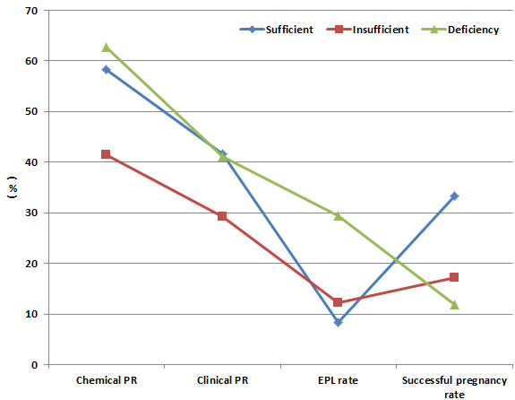

Fig. 4: Patients distributions according to ICSI outcomes among VD sufficiency statuses

Pearson's correlation analysis showed a negative significant (r=-0.347, p<0.001) correlation between serum levels of 25-OHVD and TNF-α that were estimated at enrolment (Fig. 4). The CPR and CLPR showed positive non-significant correlations with at-enrolment serum 25-OHVD levels, while showed negative significant correlations with at enrolment Serum TNF-α levels. The EPL rate showed non-significant correlations with serum levels of both markers but this correlation was negative with 25-OHVD and positive with TNF-α. However, the SPR showed a positive significant correlation with serum 25-OHVD, but the relation with serum level of TNF-α was negatively significant (Table 3).

Table (3): Pearson's correlation between at-enrolment lab findings and ICSI outcomes
Variables | Serum 25-OHVD level |  | Serum TNF-α level
 | r | p | r | p
Chemical pregnancy rate | 0.034 | 0.734 | -0.194 | 0.048
Clinical pregnancy rate | 0.057 | 0.565 | -0.197 | 0.045
The early pregnancy loss rate | 0.142 | 0.149 | 0.012 | 0.900
Successful pregnancy rate | 0.197 | 0.045 | -0.222 | 0.024

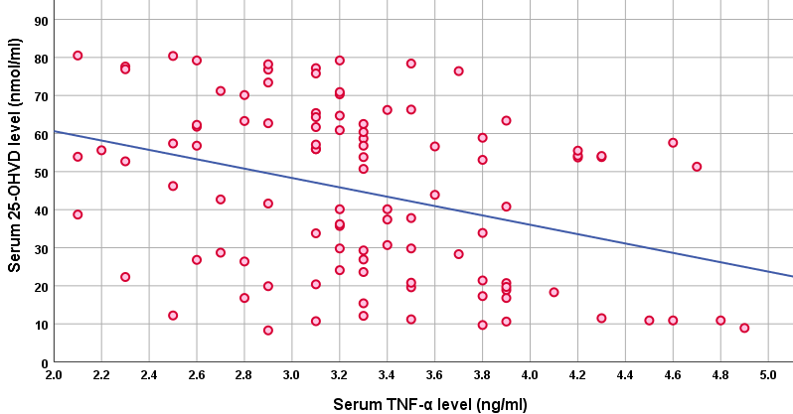
Fig. 4: Correlation between serum levels of 25-OHVD and TNF-α estimated in samples obtained at the time of enrolment of studied patients

Discussion
At-enrolment serum 25-OHVD concentration indicated VD sufficiency in only 11.5% of the studied women, while 49% had VDD; a finding indicated a high prevalence of hypovitaminosis D among women seeking pregnancy. These figures are in hand with previous studies documenting the high prevalence of VDD among infertile women ⁽¹⁷⁻¹⁹⁾.
The relation between 25-OHVD serum levels and ICSI outcomes was wave-like relation, where higher CPR was reported among women who had VDD however these VDD women showed the highest EPL rate. Similarly, a previous study detected higher miscarriage rates in women who had low serum VD concentration ⁽²⁰⁾. On the other side, women who had insufficient-to-sufficient VD concentrations showed lower CPR but also showed lower EPL and higher SPR. Further, correlation analysis showed non-significant relation between serum 25-OHVD and CPR, CLPR, and EPL rates while showing significant relation to SPR.
In line with this discrepant relation between 25-OHVD levels and ICSI outcomes, a recent study detected positive relation between serum and follicular fluid VD levels on one side and follicular fluid VD concentrations with total and MII oocyte counts, positive pregnancy test, and CLPR, but it does not correlate with miscarriage rate ⁽²¹⁾. On contrary, another recent study found no relation between serum VD levels and oocyte count or maturation rate but detected a relation between fertility and clinical pregnancy rates ⁽²²⁾.
However, the obtained results assured a possible relation between VD sufficiency and successful pregnancy after ICSI as evidenced by the results of the correlation analysis. In support of the role of VD sufficiency during IVF procedures, one study detected higher pregnancy rate during IVF procedures in women showing higher endometrial VD receptor (VDR) expression levels, especially during the implantation window of the menstrual cycle than in women with decreased expression ⁽²³⁾. Another study found VD supplemental therapy (VDST) increased serum vitamin D₃ levels with subsequent higher implantation rates during IVF ⁽²⁴⁾. Recently, a wide-population study of women undergoing ICSI detected a positive correlation between basal serum levels of 25-OHVD and basal levels of follicle-stimulating hormone, estradiol, anti-Müllerian hormone, antral follicle count, and a number of the retrieved oocytes ⁽¹⁹⁾.
In a trial to explain the relation between VD sufficiency and outcomes of IVF procedure, in a VDD animal model, VDST restored the competency of the progesterone receptor, upregulated the expressional response of the homeobox transcription factor-10/immunophilin FK506-binding protein 52 axis, which improves the uterine receptivity and endometrial decidualization at the time of implantation in a dose-dependent fashion ⁽²⁵⁾. Another animal study found VDR pathway can modulate the expression of the homeobox A10/a10 gene which is an intrinsic component of implantation, decidualization, and immunomodulation in the adult uterus ⁽²⁶⁾. Clinically, VDST for POCS infertile women improved serum VD levels with concomitant improved endometrial receptivity ⁽²⁷⁾.
The current study detected a negative significant correlation between serum levels of TNF-α and both estimated levels of 25-OHVD and ICSI outcomes, thus, VD sufficiency may impact the outcomes of ICSI especially the proper implantation that allowed a higher percentage of women had successful pregnancy through its immune modulatory effect via the reduction of serum TNF-α.
In line with these findings and suggestions, previous experimental studies documented the immune-modulating effect of VD through either regulating the activity of NF-κB, suppressing the cytokine/chemokine-like molecules, improving the balance between levels of pro-inflammatory and anti-inflammatory cytokines ^{(28, 29)}, or through decreasing TNF-α-induced inflammation via the reduction of mitochondrial fission and mitophagy ⁽³⁰⁾. In support of the immune-modulating effects of VD, a previous cross-sectional study that included healthy reproductive-age women detected a negative relationship between both total and free levels of 25-OHVD and leucocytic count and serum levels of high-sensitivity CRP ⁽³¹⁾.

Conclusion:
Vitamin D sufficiency is a prerequisite for a successful ICSI procedure. VD might exert its beneficial effects on ICSI outcomes through its modulatory action on the systemic inflammatory milieu. Pro-inflammatory cytokines had deleterious effects on ICSI outcomes and the balance between pre- and anti-inflammatory cytokines must be corrected before committing ART procedures

Study limitations
Estimation of the levels of both biomarkers in the follicular fluid and its relation to their serum levels was to be evaluated to decide as regards the use of VD supplemental therapy

References
- Haris A, Lam Y, Wootton C, Theisen A, Marzullo B, Schorr P, Volmer D, O'Connor P: Differentiation of Dihydroxylated Vitamin D3 Isomers Using Tandem Mass Spectrometry. J Am Soc Mass Spectrom. 2022 Jun 1;33(6):1022-1030. Doi: 10.1021/jasms.2c00085.
- Rastegar M, Fateh M, Rahnama A, Sheybani-Arani M, Asl A, Rajaei S: Evaluation of the relationship between vitamin D level during pregnancy and the rate of fetal heart problems: a cross-sectional study. Clin Nutr ESPEN. 2022 Oct; 51:262-266. Doi: 10.1016/j.clnesp.2022.08.018.
- Arnanz A, Garcia-Velasco J, Neyro J: Calcifediol (25OHD) Deficiency and Its Treatment in Women's Health and Fertility Nutrients. 2022 Apr 27;14(9):1820. Doi: 10.3390/nu14091820.
- Wang J, Qiu F, Zhao Y, Gu S, Wang J, Zhang H: Exploration of fetal growth restriction induced by vitamin D deficiency in rats via Hippo-YAP signaling pathway Placenta. 2022 Oct; 128:91-99. Doi: 10.1016/j.placenta.2022.08.062.
- Triantos C, Aggeletopoulou I, Mantzaris GJ, Mouzaki A: Molecular basis of vitamin D action in inflammatory bowel disease. Autoimmun Rev. 2022 Aug;21(8):103136. doi: 10.1016/j.autrev.2022.103136.
- Saul L, Mair I, Ivens A, Brown P, Samuel K, Campbell JDM, Soong DY, Kamenjarin N, Mellanby RJ: 1,25-dihydroxy vitamin d3 restrains CD4+ T cell priming ability of CD11c+ dendritic cells by upregulating expression of CD31. Front. Immunol 2019, 10: 600.
- Lee C: Controversial Effects of Vitamin D and Related Genes on Viral Infections, Pathogenesis, and Treatment Outcomes. Nutrients. 2020 Mar 30;12(4):962. Doi: 10.3390/nu12040962.
- Yan P, Song X, Tran J, Zhou R, Cao X, Zhao G, Yuan H: Dapagliflozin Alleviates Coxsackievirus B3-induced Acute Viral Myocarditis by Regulating the Macrophage Polarization Through Stat3-related Pathways Inflammation. 2022 Oct;45(5):2078-2090. Doi: 10.1007/s10753-022-01677-2.
- Stephan D, Roger A, Aghzadi J, Carmona S, Picard C, Dales J, Desplat-Jégo S: TWEAK and TNFα, Both TNF Ligand Family Members and Multiple Sclerosis-Related Cytokines, Induce Distinct Gene Response in Human Brain Microvascular Endothelial Cells. Genes (Basel). 2022 Sep 24;13(10):1714. Doi: 10.3390/genes13101714.
- Zhou W, Zhang T, Lian Y, Zhang W, Yang M, Li Y, Wang L, Yan X: Exosomal lncRNA and mRNA profiles in polycystic ovary syndrome: bioinformatic analysis reveals disease-related networks. Reprod Biomed Online. 2022 May;44(5):777-790. doi: 10.1016/j.rbmo.2022.01.007.
- Zhao X, Li Z, Yuan H, Han X, Wu J, Feng X, Zhang M, Tan J: Restraint stress and elevation of corticotrophin-releasing hormone in female mice impair oocyte competence through activation of the tumor necrosis factor α (TNF-α) system Reprod Fertil Dev. 2020 Jun;32(9):862-872. Doi: 10.1071/RD20002.
- Vaisbuch E, de Ziegler D, Leong M, Weissman A, Shoham Z: Luteal-phase support in assisted reproduction treatment: real-life practices reported worldwide by an updated website-based survey. Reprod Biomed Online. 2014 Mar;28(3):330-5. Doi: 10.1016/j.rbmo.2013.10.022.
- Heidari B, Haji Mirghassemi MB: Seasonal variations in serum vitamin D according to age and sex. Caspian J Intern Med. 2012 Fall;3(4):535-40.
- Coughlan MT, Oliva K, Georgiou HM, Permezel JMH, Rice GE: Glucose-induced release of tumor necrosis factor-alpha from human placental and adipose tissues in gestational diabetes mellitus. Diabet Med. 2001; 18:921–7.
- Steer CV, Mills CL, Tan SL, Campbell S, Edwards RG: The cumulative embryo score: a predictive embryo scoring technique to select the optimal number of embryos to transfer in an in-vitro fertilization and embryo transfer program. Hum Reprod. 1992 Jan;7(1):117-9. doi: 10.1093/oxfordjournals.humrep.a137542.
- Lopes V, Lopes J, Brasileiro J, de Oliveira I, Lacerda R, Andrade M, Tierno N, de Souza R, da Motta L: Highly prevalence of vitamin D deficiency among Brazilian women of reproductive age. Arch Endocrinol Metab. 2017 Jan-Feb;61(1):21-27. Doi: 10.1590/2359-3997000000216.
- Mogili K, Karuppusami R, Thomas S, Chandy A, Kamath M, Tk A: Prevalence of vitamin D deficiency in infertile women with the polycystic ovarian syndrome and its association with metabolic syndrome - A prospective observational study. Eur J Obstet Gynecol Reprod Biol. 2018 Oct; 229:15-19. Doi: 10.1016/j.ejogrb.2018.08.001.
- Tian M, Zeng S, Cai S, Reichetzeder C, Zhang X, Yin C, Kuang W, Cheng K, Jiang Y, Tao M, Zeng Y, Lin G, Li J, Gong F, Hocher B: 25(OH)VitD and human endocrine and functional fertility parameters in women undergoing IVF/ICSI. Front Endocrinol (Lausanne). 2022 Aug 29; 13:986848. Doi: 10.3389/fendo.2022.986848.

Ciepiela P, Dulęba A, Kowaleczko E, Chełstowski K, Kurzawa R: Vitamin D as a follicular marker of human oocyte quality and a serum marker of in vitro fertilization outcome. Journal of Assisted Reproduction and Genetics, 2018: 35: 1265–76.
- Ozyurt R, Karakus C: Follicular fluid 25-hydroxyvitamin D levels determine fertility outcome in patients with polycystic ovary syndrome. Taiwan J Obstet Gynecol. 2022 Jul;61(4):620-625. Doi: 10.1016/j.tjog.2022.03.041.
- Faisal R, Alhalabi M, Alquobaili F: Correlation between 25-hydroxy vitamin D levels in women and in vitro fertilization outcomes: A cross-sectional study. Ann Med Surg (Lond). 2022 Jul 12; 80:104126. Doi: 10.1016/j.amsu.2022.104126.
- Guo J, Liu S, Wang P, Ren H, Li Y: Characterization of VDR and CYP27B1 expression in the endometrium during the menstrual cycle before embryo transfer: implications for endometrial receptivity. Reprod Biol Endocrinol. 2020 Mar 17;18(1):24. Doi: 10.1186/s12958-020-00579-y.
- Espinola M, Bilotta G, Aragona C: Positive effect of a new supplementation of vitamin D3 with myo-inositol, folic acid, and melatonin on IVF outcomes: a prospective randomized and controlled pilot study. Gynecol Endocrinol. 2021 Mar;37(3):251-254. Doi: 10.1080/09513590.2020.1760820.
- Ashour H, Gamal S, Sadek N, Rashed L, Hussein R, Kamar S, Ateyya H, Mehesen M, ShamsEldeen A: Vitamin D Supplementation Improves Uterine Receptivity in a Rat Model of Vitamin D Deficiency: A Possible Role of HOXA-10/FKBP52 Axis.
- Ekanayake D, Małopolska M, Schwarz T, Tuz R, Bartlewski P: The roles and expression of HOXA/Hoxa10 gene: A prospective marker of mammalian female fertility? Reprod Biol. 2022 Jun;22(2):100647. Doi: 10.1016/j.repbio.2022.100647.
- Menichini D, Forte G, Orrù B, Gullo G, Unfer V, Facchinetti F: The role of vitamin D in metabolic and reproductive disturbances of polycystic ovary syndrome: A narrative mini-review. Int J Vitam Nutr Res. 2022 Mar;92(2):126-133. Doi: 10.1024/0300-9831/a000691.
- Biriken D, Ayral P, Yazıhan N: The Role of Vitamin D3 on the Immune Responses of Monocytes. Mikrobiyol Bul. 2021 Jul;55(3):406-414. Doi: 10.5578/mb.20219809.
- El-Boshy M, Alsaegh A, Qasem A, Sindi R, Abdelghany S, Gadalla H, Reda D, Azzeh F, Idris S, Ahmad J, Refaat B: Enhanced renoprotective actions of Paricalcitol and omega-3 fatty acids co-therapy against diabetic nephropathy in the rat. J Adv Res. 2021 Aug 18; 38:119-129. Doi: 10.1016/j.jare.2021.08.010.
- Chen Y, Sung H, Chuang T, Lai T, Lee T, Lee C, Lee I, Chen Y: Vitamin D3 decreases TNF-α-induced inflammation in lung epithelial cells through a reduction in mitochondrial fission and mitophagy. Cell Biol Toxicol. 2022 Jun;38(3):427-450. Doi: 10.1007/s10565-021-09629-6.
- Chu C, Tsuprykov O, Chen X, Elitok S, Krämer B, Hocher B: Relationship Between Vitamin D and Hormones Important for Human Fertility in Reproductive-Aged Women. Front Endocrinol (Lausanne). 2021 Apr 14; 12:666687. Doi: 10.3389/fendo.2021.666687.
- Kamimura D, Yimer W, Shah A, Mentz R, Oshunbade A, Hamid A, Suzuki T, Clark 3rd D, Waller J, Fox E, Correa A, Butler J, Hall M:
Vitamin D Levels in Black Americans and the Association With Left Ventricular Remodeling and Incident Heart Failure With Preserved Ejection Fraction: The Jackson Heart Study. J Card Fail. 2022 Jul 26; S1071-9164(22)00650-9. Doi: 10.1016/j.cardfail.2022.07.049.
- Wang J, Qiu F, Zhao Y, Gu S, Wang J, Zhang H: Exploration of fetal growth restriction induced by vitamin D deficiency in rats via Hippo-YAP signaling pathway. Placenta. 2022 Oct; 128:91-99. Doi: 10.1016/j.placenta.2022.08.062.
- Ekapatria C, Hartanto B, Wiryawan P, Tono D, Lumban T, Meita D, Arief B, Cornelius M: The Effects of Follicular Fluid 25(OH)D Concentration on Intrafollicular Estradiol Level, Oocyte Quality, and Fertilization Rate in Women Who Underwent IVF Program. J Obstet Gynaecol India. 2022 Aug;72(Suppl 1):313-318. Doi: 10.1007/s13224-021-01615-6.
- Paravati R, De Mello N, Onyido E, Francis L, Brüsehafer K, Younas K, Spencer-Harty S, Conlan R, Gonzalez D, Margarit L: Differential regulation of osteopontin and CD44 correlates with infertility status in PCOS patients. J Mol Med (Berl), 2020 Dec;98(12):1713-1725. Doi: 10.1007/s00109-020-01985-w.
- Fang X, Lu F, Wang Y, Guo L, Zhang Y, Bai S, Kwak-Kim J, Wu L: Anti-Ro/SSA and/or anti-La/SSB antibodies are associated with adverse IVF and pregnancy outcomes. J Reprod Immunol. 2022 Feb; 149:103459. Doi: 10.1016/j.jri.2021.103459.

